2413. Smallest Even Multiple

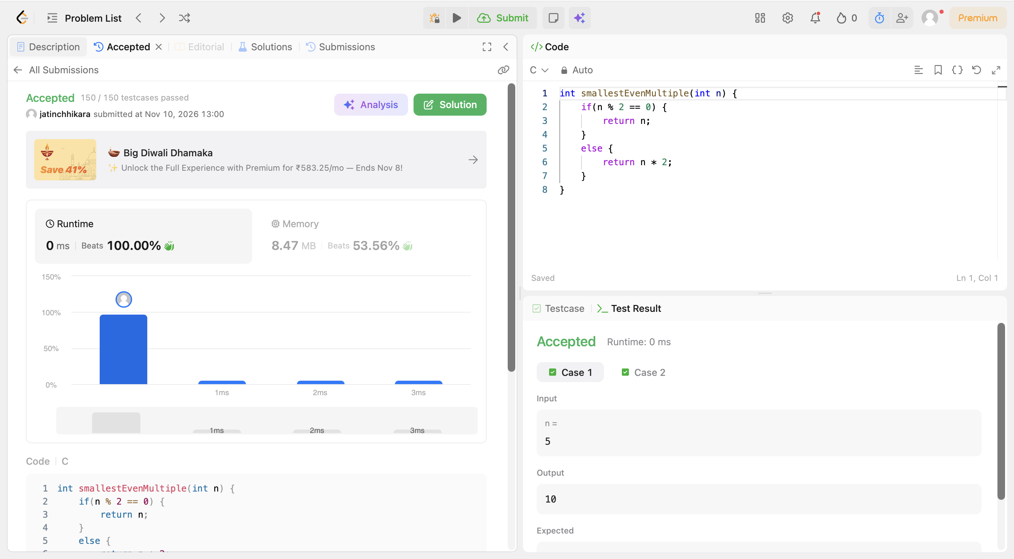
Code:
int smallestEvenMultiple(int n) {
if(n % 2 == 0) {
return n;
}
else {
return n * 2;
}
}

